Order Of Lenten Service

Opening Hymn: TLH 153

Reading: Lent V

The History of the Passion of our Lord

Sermon Hymn: TLH 656

Sermon Text: Mark 13:19-23

For The Elect’s Sake

Prayer

Holy Communion

The Lord's Prayer

The Blessing

Closing Hymn: TLH 155

* * * * * * * * * * * * *

Bible Study: Lambs: Shrew
Sheep: Proverbs 23:6-11

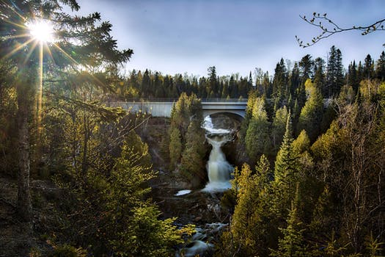

Spring In Duluth, MN

Water
Of
Life

22 March 2020

W A T E R O F L I F E

Independent Christian Church—Conservative Lutheran Doctrine

Worship Service: 9:30 a.m. Bible Study: 10:45 a.m.

Larry Cooper, Pastor E-Mail address:
111 N. Ridge Road lcooper@wateroflife.cc
Coon Valley, WI 54623 Web Site:
www.wateroflife.cc

* * * * * * * * * * * * * * * * * * * * * * * * * * *

Sermon Text: Mark 13:19-23

For The Elect’s Sake

* * * * * * * * * * * * * * * * * * * * * * * * * * *

Mark 13:19 For in those days shall be affliction, such as was not from the beginning of the creation which God created unto this time, neither shall be.
:20 And except that the Lord had shortened those days, no flesh should be saved: but for the elect's sake, whom he hath chosen, he hath shortened the days.
:21 And then if any man shall say to you, Lo, here is Christ; or, lo, he is there; believe him not:
:22 For false Christs and false prophets shall rise, and shall shew signs and wonders, to seduce, if it were possible, even the elect.
:23 But take ye heed: behold, I have foretold you all things.

Ephesians 1:1-12

Ephesians 1:1 Paul, an apostle of Jesus Christ by the will of God, to the saints which are at Ephesus, and to the faithful in Christ Jesus:
:2 Grace be to you, and peace, from God our Father, and from the Lord Jesus Christ.
:3 Blessed be the God and Father of our Lord Jesus Christ, who hath blessed us with all spiritual blessings in heavenly places in Christ:
:4 According as he hath chosen us in him before the foundation of the world, that we should be holy and without blame before him in love:
:5 Having predestinated us unto the adoption of children by Jesus Christ to himself, according to the good pleasure of his will,
:6 To the praise of the glory of his grace, wherein he hath made us accepted in the beloved.
:7 In whom we have redemption through his blood, the forgiveness of sins, according to the riches of his grace;
:8 Wherein he hath abounded toward us in all wisdom and prudence;
:9 Having made known unto us the mystery of his will, according to his good pleasure which he hath purposed in himself:
:10 That in the dispensation of the fulness of times he might gather together in one all things in Christ, both which are in heaven, and which are on earth; even in him:
:11 In whom also we have obtained an inheritance, being predestinated according to the purpose of him who worketh all things after the counsel of his own will:
:12 That we should be to the praise of his glory, who first trusted in Christ.

